Cagaoan, Crischin Charm C. December 8, 2019

Militar, Marcus G.

2ECE-C

Problem 1: Python

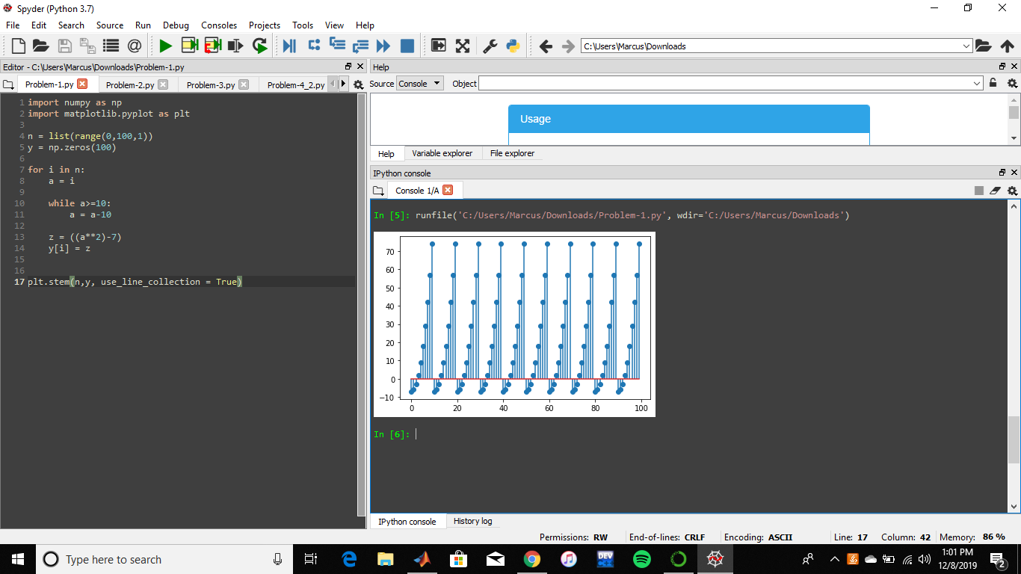

Description:

The graph of f(n) is repeated. It starts at the y-coordinate of -7 and as it reaches 74, the graph starts again at -7. On the other hand, the x-coordinates range from 0 to 99 and have equal spaces of 10 units with respect to the y-coordinates.